Python Assignment 3: While Loop, For loop and Function

While loop & Control Statements :
(else, break, continue, pass)

Number Guessing Game
Problem Statement: Create a Python program that implements a simple number
guessing game using a while loop. The program should make use of control
statements such as else, break, and continue.
- Set Up the Game:
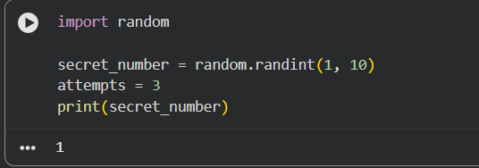
- Prompt the User:
- Implement the Guessing Logic:
- Control Statements:
★ Use continue
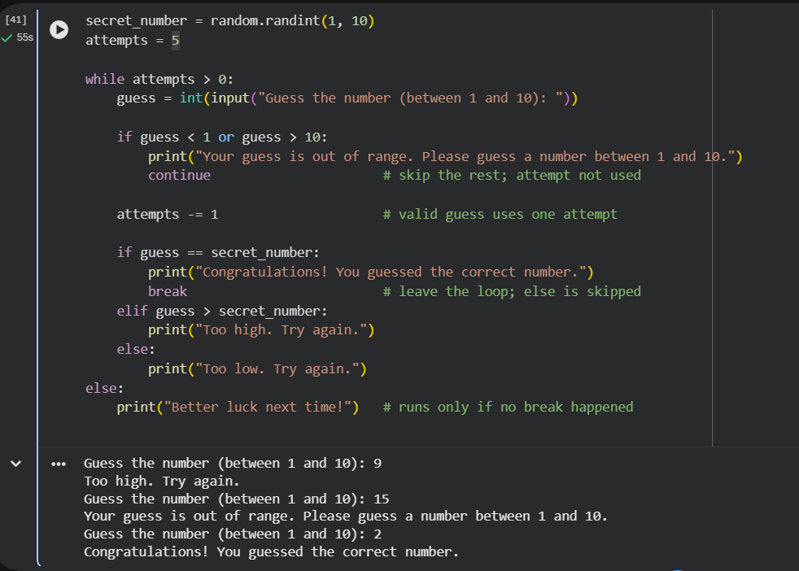
For Loop:

Multiplication Table Generator
Problem Statement: Create a Python program that generates and prints a
multiplication table (from 1 to 10) for a given number using a for loop and the range
function.
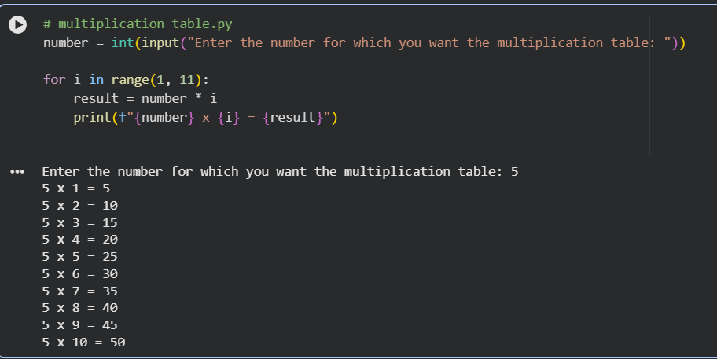
Function:

BMI Calculator
Problem Statement: Create a Python program that calculates the Body Mass Index
(BMI).
Hint: BMI = weight (kg) / [height (m)]2

